# Catalog Project

## Overview:

You will be creating a simple PHP/MySQL application that catalogs a collection of similar items. You may catalog anything you like as long as your initial planning is approved.

There will be at least 18 hours of supervised lab time allotted for this project. The instructor will also demo topics of relevance to this project during that work time. You are encouraged to seek instructor feedback and guidance during the work classes.

This assignment will incorporate many of the concepts you have learned in this class.

THIS PROJECT IS WORTH 30% OF YOUR FINAL MARK.

## Notes:

1. Topics used in Labs 2 – 7 may not be used
2. It MUST be your own original concept and you must resource your own content.
3. You may not do an image gallery, or dogs or music since we did demos on those.

**\* PLEASE ENDEAVOR TO BE AS ORIGINAL AS YOU CAN HERE SO THAT YOUR PROJECT MAY STAND OUT AS A GOOD PORTFOLIO PIECE AND NOT LOOK LIKE IT’S JUST A CLASS PROJECT.**

Some suggestions for items are:

* Places (vacations spots, nightclubs, etc.)
* Recipes
* Breeds of cat/hamster/gecko/whatever.
* Websites.
  + Screenshots or logos could be your imagery.
  + Could be a list of tutorial websites, etc.
* Product Catalog:
  + Could be garage-sale items you have collected.
  + Could be a specialty store of some sort.
  + Favorite clothes, shoes, hats, makeup, electronics
    - must be from more than one manufacturer/brand
* Etc.

Each item must be represented by the following info:

* Image(s): It will be up to you to source fair use image(s). Your own are better.
* Title:
* Description:
* Categories
  + all items must have some category associated with it so that like items can be grouped (like genre, clothing category, continent, country, weather, etc).
* Any additional info such as:
  + Year of release, production company/studio, ratings, tags, length, etc.

Feel free to use Booleans such as:

* Age 18+
* Platforms (we’ll use games platforms as an example) – Each platform that the game can be played on would be a 1 in that field:
  + Windows
  + Xbox
  + Playstation
  + Etc.
* At least one numeric value that you can use to demonstrate a BETWEEN query.
  + Examples:
    - Artist earnings.
    - Product Price
* Please aim to have at least 8 - 10 fields of information for all items.

EACH PIECE OF DATA ABOVE WILL HAVE ITS OWN FIELD IN YOUR DATABASE.

YOU MUST HAVE 25 OR MORE ITEMS TO POPULATE YOUR CATALOG. Catalogs without 25 items will NOT be marked.

## Functionality:

### The admin section must allow the following functionality:

* Insert a new item.
  + Validate that each new item has the required and correct information.
  + Upload a single image to represent that item.
* Edit an existing item.
* Delete an item.

The admin section MUST be secured. Only an authenticated administrator can access it. A new table catalog_users will be used with two entries – 1 for you and 1 for me. Register user not required

### The public display must show the following:

* An introductory homepage that explains what the project is about. Feel free to describe the content as well as what you are demonstrating using PHP/MySQL.
  + Suggestion: Create feature boxes that link to some category or item.
  + You MUST have a couple paragraphs of original content describing your project.
* A main display page that can show:
  + All items.
  + Filtering of results by any 3 factors that are appropriate to your project. We have seen filtering by genre, year, decade, and other possibilities in the CD Catalog.
* Search feature.
* Some kind of single-item display page: full-size image, description, all info.
* Graphical output:
  + Thumbnails for list view plus larger image for a single item view.
* Single item view:
  + If the user selects an item from a listing, they can see just that one item with all info.
* Both index page and/or display page should present interesting uses of MySQL queries in a way that allows for efficient filtering or presentation of your content.

## Marking:

A mark out of 30 will be given. This will represent 30% of your final mark in this course.

*Project MUST be dynamic with all content stored in the database and a basic Insert Item page enabled or else no marks will be given.*

### Planning documentation (Due first full week of project): [5 marks]:

* Technical demonstrator of MySQL output filtering shown (completed CD Catalog work-through).
* A Planning Document with the following:

1. A several paragraph description of what items you are cataloging, how you plan to display them, and anything else of interest.
2. One sample item with all information you plan to show including an image.
3. A basic flowchart of your database table showing what data will be stored. A screen capture of phpMyAdmin with the completed table is OK.
4. Must be submitted to moodle for approval

Your Catalog Project concept MUST be approved first before moving on.

### PHP/MySQL input, edit, and delete functionality [5 marks]:

* Good admin section. An admin should be able to insert, delete, edit, etc.
* Admin section is secured.
* All necessary validation such as required-field, min-length, file types, etc.
* Correct form elements used.
  + If user has to select one value from several possibilities, then a <select> or radio should be used, NOT a text input.
  + Checkbox/radios can be used for Booleans (yes/no).
* A successful new item insert results in:
  + Image uploaded & image copies created in necessary folders.
  + All necessary data can be seen in the database.
* Edit Item
* Delete Item

### Content [5 marks]:

* All info for at least 25 items including titles, images, descriptions, and several other fields of info.
* Good description of project, genres, etc. on homepage.
* Multiple image sizes utilized.

### Overall design/usability [5 marks]:

* Visual design is appealing and professional.
* A true responsive layout that can be accessed from mobile devices.
* All content is easily accessible; all text readable.
* A single item view must be available as well as list views.
* The database filters are natural categories that work with the content and lead the user into believing they are navigating a site, NOT querying a database.
* Thumbnails are well designed and implemented into the design.
* The Home page has an interesting layout that entices the user to explore further.
  + Intro to this project.
  + Featured items, categories, etc. Graphical features recommended.
  + Main navigation present.

### MySQL filtering and navigation, features/widgets [5 marks]:

* All items are shown from a well thought out system of categories and other cataloging parameters.
  + One of which should show a range of values (MySQL BETWEEN). If prices or any other values do not seem to work with your content, try a rating system.
* Interesting use of any MySQL generated widgets, features or teaser items.
  + Pagination (if you can make it work; the one script we went through cannot be used without extensive modification).
* Interesting query feature(s) that you have researched yourself and implemented and that we have not covered in class.
* Do NOT show too many filters that result in the user constantly trying filters that result in no results. If an advanced filtering system does not work for your content, use a simpler one.
  + You could have a dedicated search page however with advanced filters, an advanced search, etc.

Additional Features and media [5 marks]: Impress classmates, employers, and teachers with any features you would like to figure out.

Examples:

* image cropping
* multiple images with lightbox
* categories in separate table to easily choose from list
* user comments on items that appear on details page (would need register/create/edit/delete)
* Anything else you would like to try; perhaps consult the instructor first if you’re not sure about it.

Marking Rubric: Since many components above are out of 5 marks, here is a guide as to how they will be assessed.

1. Fail: Something attempted, but not-functional, or tasks not completed.
2. Poor effort: Bare minimum done; some functionality, but not optimum. No originality/research/ creativity/attention-to-detail *shown.
3. Average: Tasks completed; fully functional but little originality/research/ creativity/attention-to detail shown.
4. Good: tasks completed; some originality/research/ creativity/attention-to-detail, but instructor can still suggest improvements that should have been made.
5. Excellent: All tasks done; originality/creativity shown; instructor cannot suggest improvements.

*originality/research/ creativity/attention-to-detail:* This refers to a student…

* Figuring out something for them self as opposed to copy/pasting code snippets given to them in class.
* Designing something to a professional level in terms of layout, usability, text formatting, styling, etc.
* Resourcing and formatting content as if this is a professional product and not just an assignment.

If there are any concerns with this marking criterion as it relates to your project, please discuss your project with the instructor during any of the work classes.

## Due Dates:

### Planning Documentation - 5 marks

* See Moodle for assignment due date and submission guidelines.
  + Due date will be during 1st full week of work time.
* Your proposed concept MUST be approved by the instructor before you can continue work on this project.
* Document completed with the following:
  + A several paragraph description of what items you are cataloging, how you plan to display them, and anything else of interest.
  + One sample item with all information you plan to show including an image.
  + A basic flowchart of your database table showing what data will be stored. A screen capture of phpMyAdmin with the completed table is OK.
* Show completed filtering demonstrator (CD Catalog work through) during work class.

### Admin section: PHP/MySQL input, edit, and delete functionality – 5 marks

* See Moodle for assignment due date and submission guidelines.
  + Due date will be during 2nd full week of work time.
* The insert new catalog item page is completed with:
  + All necessary form elements.
  + All validation, image upload.
  + Image copies created in necessary folders.
  + All necessary data can be seen in the database.
* Edit Item
* Delete Item

## Completed Project - 20 marks

* See Moodle for assignment due date and submission guidelines.
  + Due date will be the end of the last week of classes for the term.
* Final Submission should include:
  + Moodle
    - URL of project.
    - Admin URL and username/password.
    - Description of features you have integrated so nothing is missed while marking.
  + Zip file submitted to your dropbox named catalog.zip

## Interactive Design

The layout of your project is ultimately up to you, but here are some suggestions for how to structure your main output pages.

Home Page:

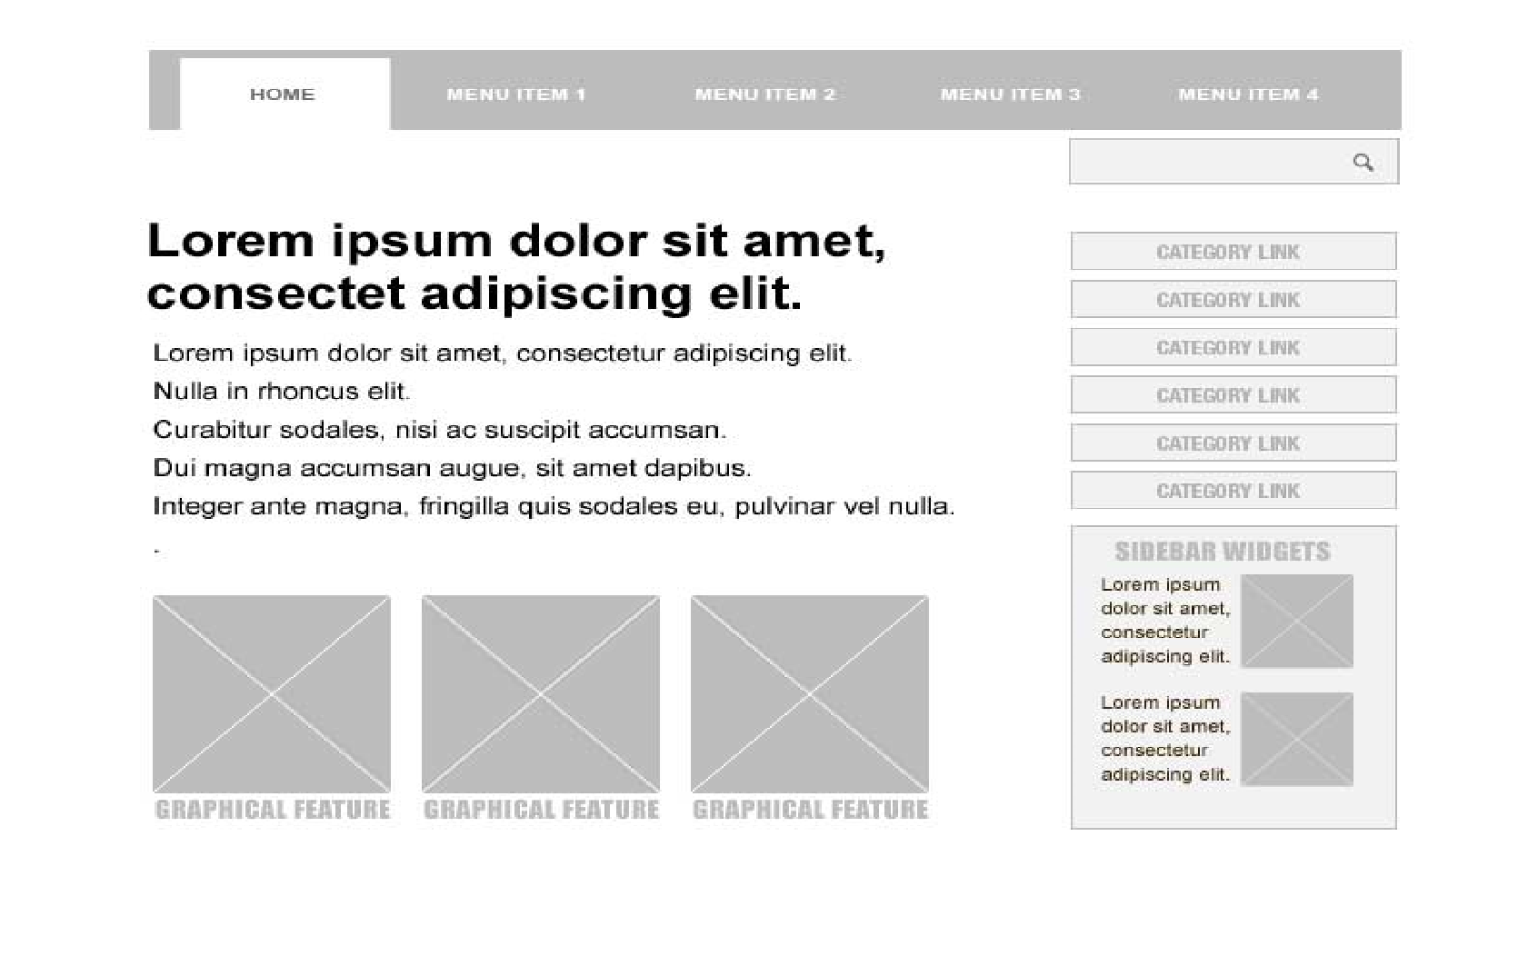

Thumbnail View of Items: This will be the main page that responds to all your linked DB filters and shows the user a wide range of items depending on what they select from your Category Links. 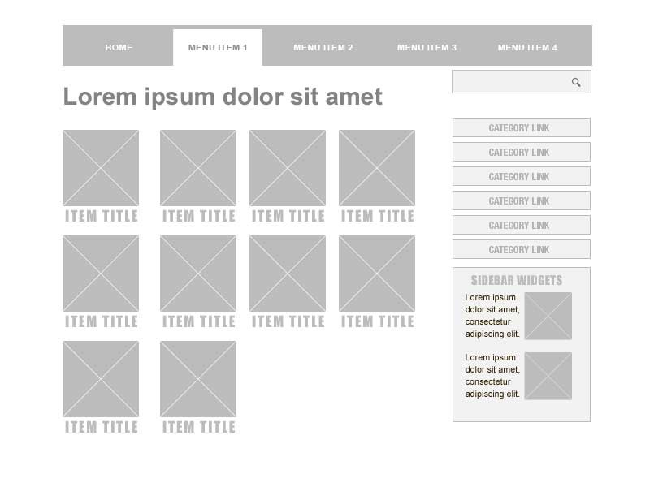

Single Item View 